CHESS TEACHING TOOL

A Level Computer Science NEA

Oliver Abbott 3827
Harington School 25345
Contents
Analysis 2
Context of Problem 2
Interview 2
Existing System 2
Requirements 2
Acceptable Limitations 2
Success Criteria 2
Qualitative Criteria 2
Quantitative Criteria 2
Documented Design 3
Description 3
Interface Design 3
Algorithms 3
Technical Solution 4
Testing 5
Test Table 5
Evidence 5
Evaluation 6
Analysis of Criteria 6
End User Feedback 6
Final Thoughts 6

Analysis

Context of Problem
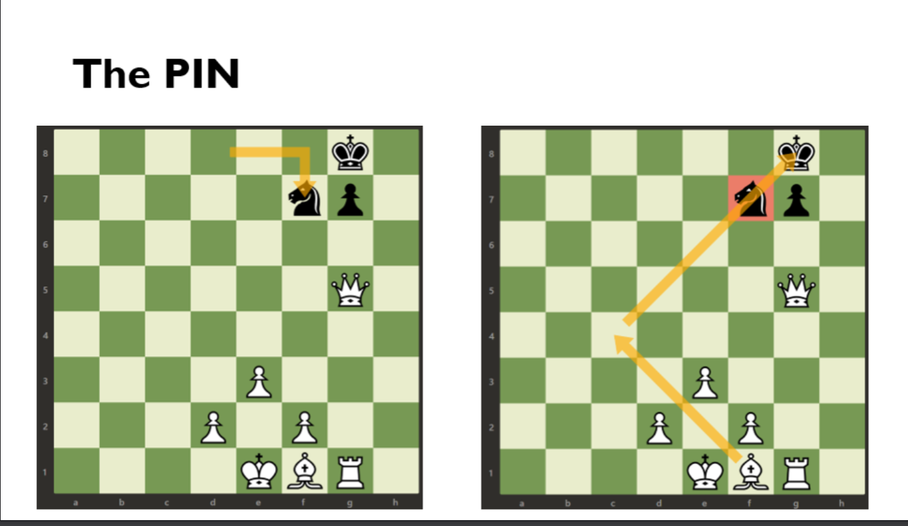
My secondary school from year 7 to 11 with around 1100 students. They have an elective on Wednesday afternoons after lunch they go to a lesson they pick from art, sports or cultural one of these electives is a chess elective ran by Mr Russel. Currently he uses a set of power points to show the current moves and positions. Some problems with that include not being able to see letters and number position on the board as the screen shots use chess.com with grey on black that are hard to see at the end of a class room and the reason he does not use chess.com’s website teaching tool is that the school has a very strong firewall that means chess.com cannot be logged into while on the schools network. This means Mr Russel requires an offline tool that can import and export files from the interface and while the files are in use and displayed they need to be able to be interacted with in clear visible text and be able to move pieces, flip the board, show valid moves and draw an arrow to show where the pieces can move. As show in the screen shot of one of the PowerPoint slides on the right. It is hard to demonstrate all the moves you can do and you can’t easily see the checkmate white can make with the queen with this move or the place you should move the queen on the grid as the grid values are small and hard to see.

Analysis of Problem
The problem that currently exists is that chess.com can’t be opened or used on the school’s network due to this we cannot use the teaching tools on chess.com and thus not be able to move the pieces, draw arrows and set up the boards and explore moves the student wants to try. The PowerPoints are too inconvenient and have far too small text to read easily for the board position when you are not right next to the screen and you can only look at preset moves already on the power point. This is a problem like with the chess.com you cannot explore students moves which is not good for teaching and it is harder for people with people not sitting at the front of the class when they want to participate as they cannot easily read the positions for where they want the piece to go to try a move.

Interview
My end user will be Mr Russel a computer science teacher for GCSE and A-levels who runs and teaches the chess elective.

Q: What’s the problems you are facing currently?
A: “Chess.com current cannot be use on are schools network as it is blocked from inside the school and PowerPoints currently don’t work that well as we cannot explore moves that student suggest and the power points are hard to see when you are not sitting at the front of the classroom so students at the back cannot easily tell me what moves they are thinking as they cannot see the grid positions as chess.com is designed for online learning even if we could use it in school is not easy for students in the classroom to learn through it.”

Q: What do you want to do with this tool?
A: “I would like the tool to be able to work fully offline that I can load and save boards in a friendly way that is easy to work with. I also would like it to be able to draw arrows to show where the pieces can go and when you move a piece, I would like it to show if that move is valid or not with something visible to teach how pieces can move. I also need to easily be able to see both sides of the boards from a button.”

Q: What are the requirements to teach with the tool?
A: “The tool needs to be easy to see from the back of the classroom so the students can see the board and the placement at the back of the class and I need to easily load and select files as well as create them from the software and I need to have most of the functionality of sites like chess.com but offline so I can use them while on the school network and easily demonstrate the moves that can be played.”

Q: What are other tools that you have tried and why have they failed for you?
A: “I tried to use chess.com but as discussed earlier it was not a good fit for me due to the school’s computer network blocking it. Then I moved onto trying and what I current use is power points but that is not favourable as the text is very small and hard to read from the back and we cannot play moves the students have selected but are not already done.”

Existing System
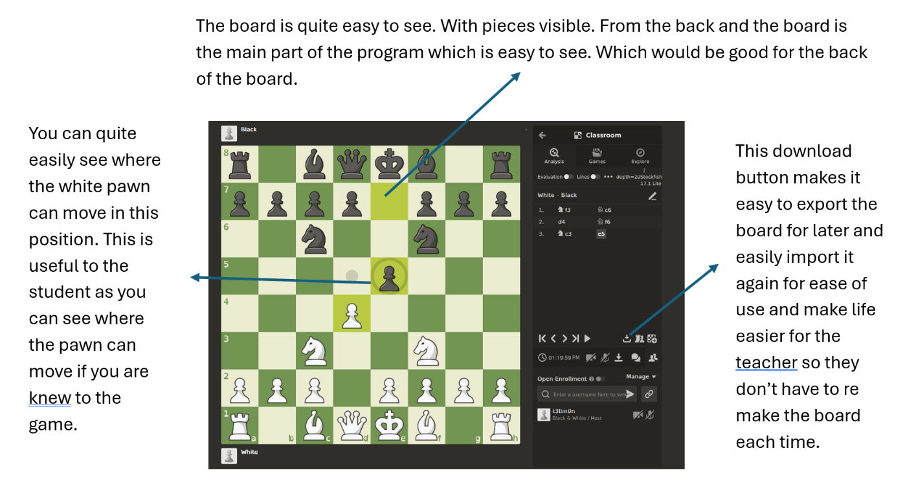
Chess.com

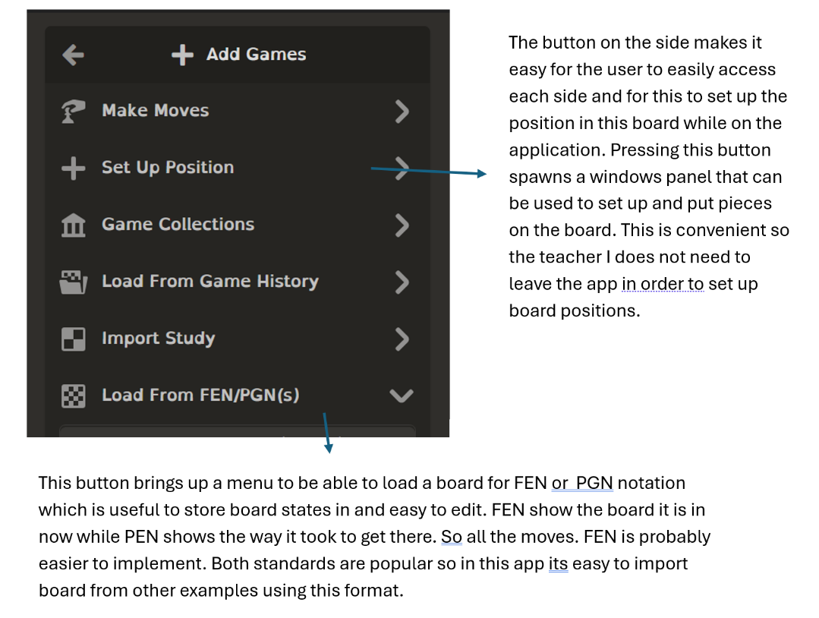

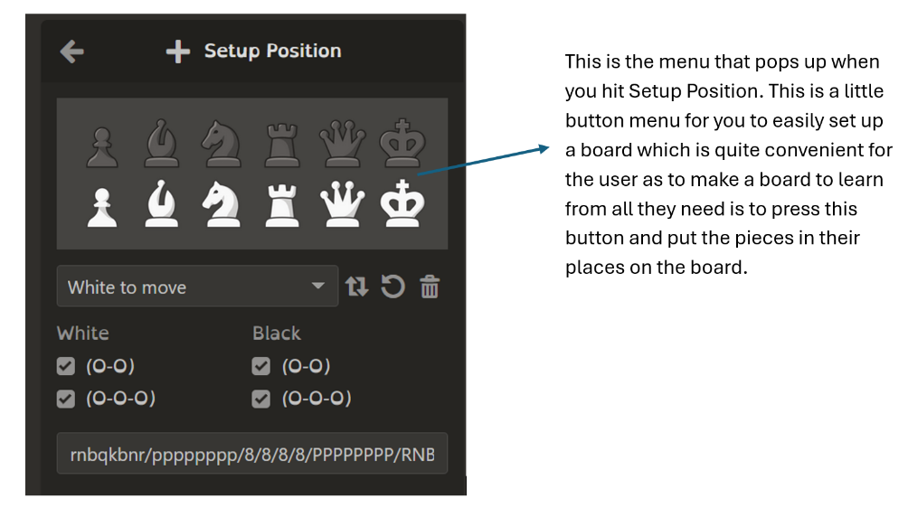

Lichess

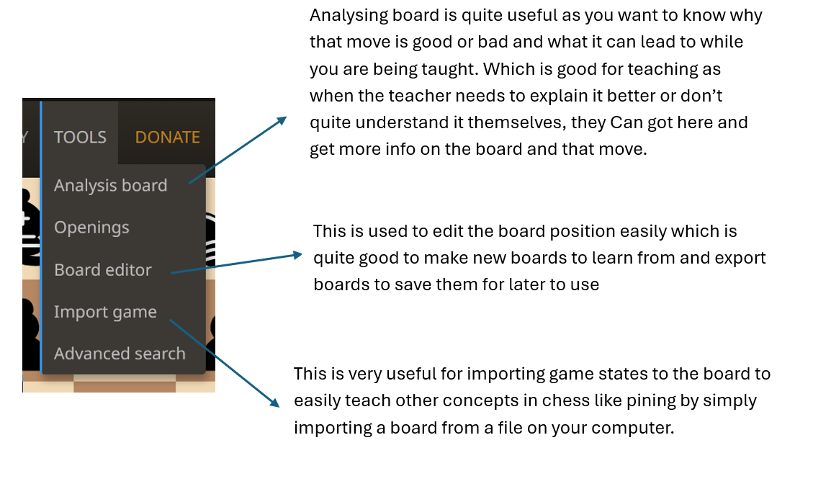

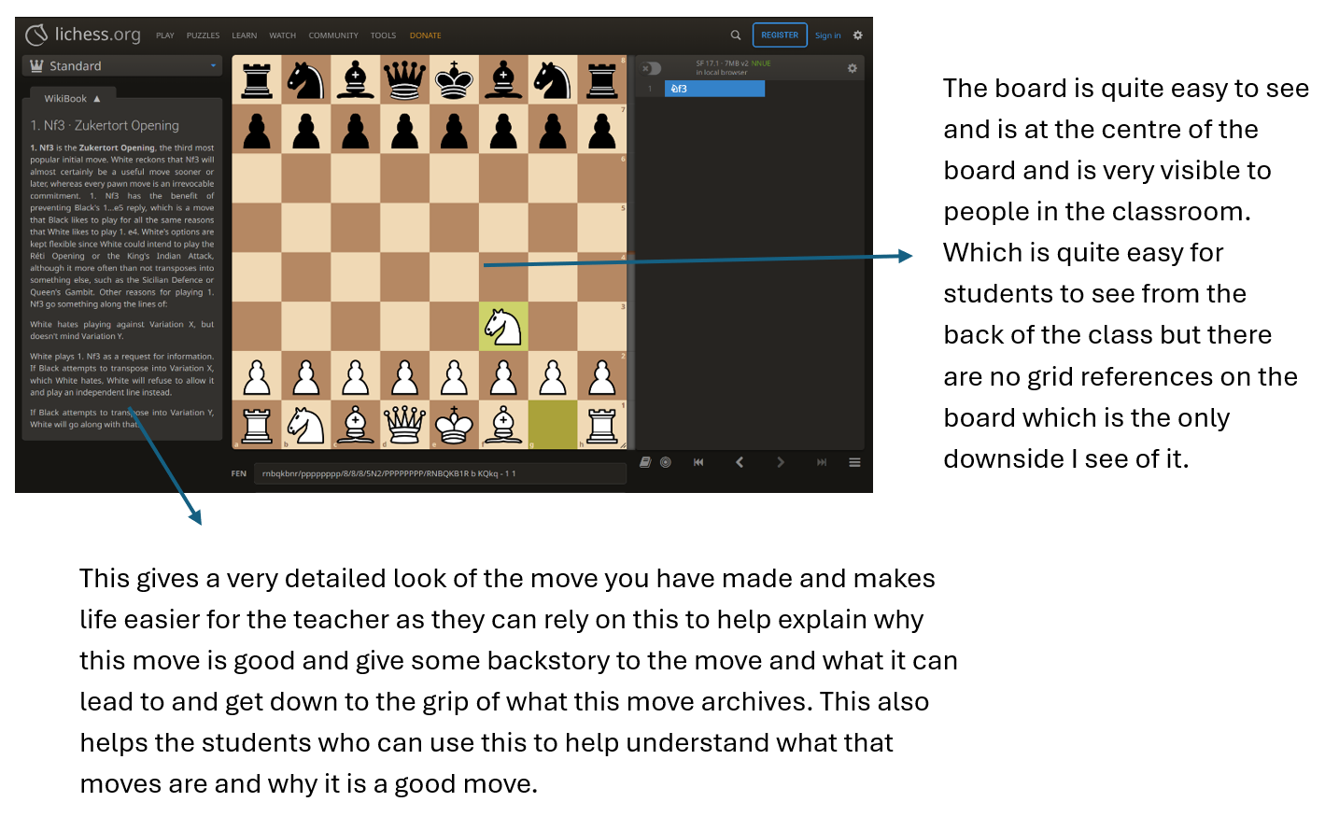
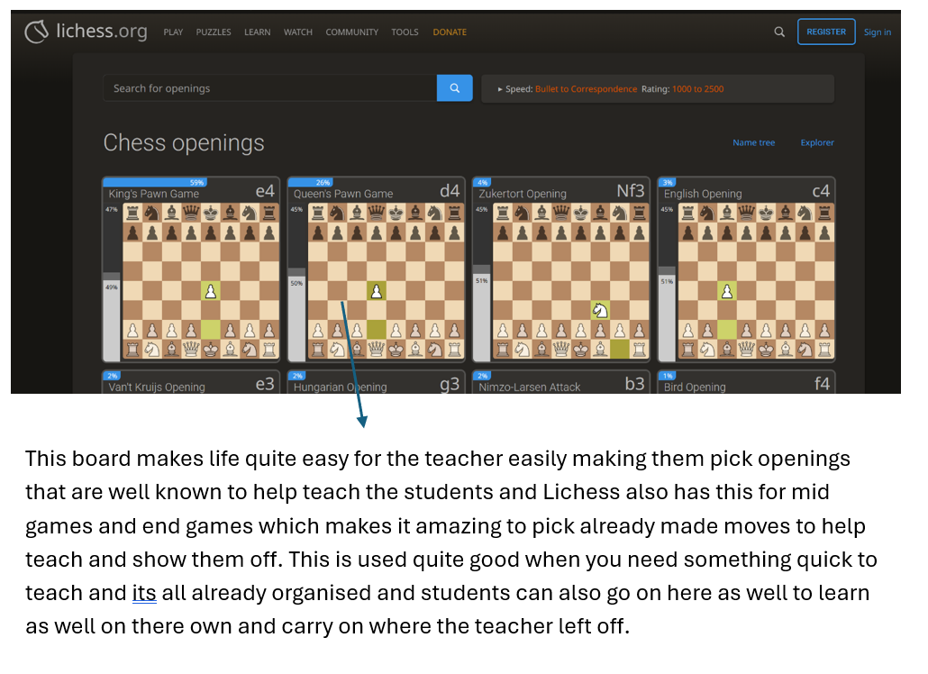

Real Chess Board
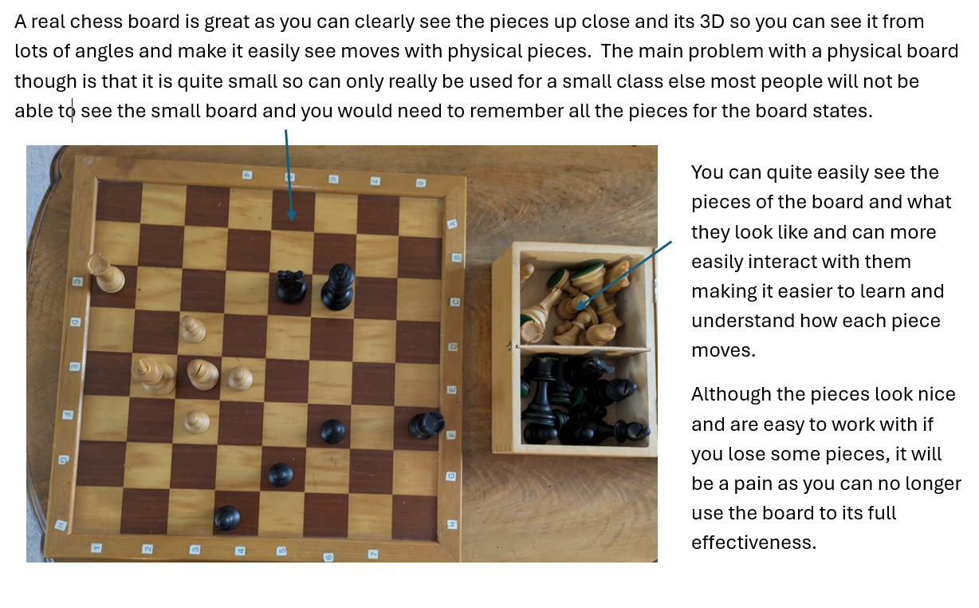

Identification of Users
Teachers will be using my system the most. There technology level would be quite good so there is no need to baby proof the application files systems creation. They will be using the tool to teacher the students in the elective chess. This will impact the size and structure of my graphical user interface which means it must be big enough so see far away and have easily accessible buttons to show what the teacher is doing and the program will be used on multiple device with different screen sizes for creation of boards and to be put on the big screen the windows must be scaled with multipliers and not used numbers for a one case screen.

Requirements
From the interview. The program needs an easy interface to interact with so teachers can use it quite easily to teach and it is easy for the students to understand when looking at it. The program also would need a way to import and export board files to use in the program so the teacher can easily load new board states to teach from easily and for that we also need a way to create a board inside the program so you can export that board to the computer for it to be imported later. Based on the interview we need to make it easier to see what moves need to be made we also need a way to draw arrows onto the board to easily demonstrate what moves can be made from the position. As this program is going to be used to teacher, based on the existing system analysis and interview process, we need a clearly visible and easy to read for the grid references for the students to read at the back of the classroom. Aswell as this is a teaching tool we need to easily be able to see the opponent’s side of the board easily so we would need a switch button so the program can easily switch to the other persons perspective of the board so students can easily see what the other person is looking at and moves they can make for this we also need a way to see if a move is valid. So, for the program there needs to be a signifier to show if a move is valid at that position so the new students to chess can easily see if that move is valid.

Acceptable Limitations
My main limitations will be with the checking the validity of the pieces movements due to there being some special case moves like castling and en passant which need special use cases to check there validity including a variable for the queen and rook as well as the positions of the pawn which I don’t think is reasonable for this level of project as you would be needing some fixes that are unreasonable for a A-Level project as you would need a way to store if the queen has moved and if the rook has moved and move two pieces at once while checking if both the spaces next to it are free and the en passant will also be a limitation I am willing to put in place as you need to check the position of the pawn that about to be taken and if it moved 2 squares as its last move and the position of the pawn which would take a lot of work for a small feature so I will not be adding it and will make that moves also not in my version and due to the pawn having so many conditions for if any move is valid like if the not moved they can move two squares forward and only being able to take sideways I will not check if any of thoughts are valid and just let is say yes due to the complication of checking the moves.
I also think it is unrealistic to be importing using a ready used format like FEN or PGN as for PGN for example you will need to play through the whole game to get the current board state which is a whole project on its own and would be unrealistic and for FEN notation it has a lot of unneeded information at the end as we are not going to implement the castling feature or any of the other rules that are quite advance for beginners like the half move clock but I do not think it is unrealistic to implements the way it stores the pieces so I will be using the FEN notation but without the extra bits at the end as I think that much is unreasonable for me to implement and is an acceptable limitation for the project.
My last acceptable limitation will be drawing more than one arrow at a time as this requires me to store all the positions of the arrow in a list of data which is hard to keep track of as well as drawing all of them onto the board. I think this would get quite messy quickly and be very complicated to implement so I will be only adding a way to draw one arrow at a time and making it so that the until the arrow is reset it will use the same start position to make the arrow code more simple and easier to implement for the project and for the same reason when I flip the board I will not be flipping the arrow as well due to the complexity it will take.

Success Criteria
- Show a chess board
- loaded images as the pieces with the colour of the pieces visible in the images loaded
- The pieces must be able to move with user input
- Moves must be show as valid or invalid using the acceptable limitations as a guide
- A clear and easy to read area for the grid references to be read from on the side of the board
- line up to each square of the board to the grid position
- The top part of the program has buttons to import and export a board
- The export and input must be files stored in the user’s computer.
- Flip the board with a button
- Change the sides of the board with the references to flip is to from A-H to H-A
- Change the sides of the board with the references to flip is to from 1-8 to 8-1
- Board must be flipped in where the board is reflected in the line y = x and then y = -x + 8 so the board is fully reflected. y = 0 and x = 0 at the first square
- When draw arrow is pressed change its buttons colour
- Draw an arrow on the board when draw arrow is pressed.
- The arrow must be clearly visible above the board without the board disappearing completely
- The arrow must be draw on top of the board itself.
- Use the first button as the start of the arrow
- Use the second button when the end of the arrow is
- When the user clicks a new button while draw arrow is active change the new end to the new location
- Remove the arrow and forget it position when draw arrow is re pressed
- The import button must pop open a window to access the user’s files graphicly
- The user can select the file they want to import
- Error handling for anything unexpected with reading or writing a file.
- Read the file
- Parse the file in to get the board state
- Use the imported board state to put it onto the board using text labels text labels.
- Load images for each for the pieces
- Load the parsed information onto board
- The export button must be able to read the board
- The board must be read into an array to save into the file.
- The user must be propped with a graphicly way to save the file
- The file must be saved in the directory selected by the user
- The file also must be saved with the user selected name
- The file must then be opened and written into with the data gotten from the array for the board
- Any errors must be handled and displayed to the user.

Documented Design

Description
To solve the problem, I will make an offline chess teaching tool that can import and export chess boards from the program and make it so you can make a chess board inside the board state and store it in a human readable file. I will also make it so the grid references can be read easily from afar and you can easily flip the board with one click of a button and another button to draw an arrow onto the board easily to easily demonstrate the moves. There will also be a way to see if the last move is valid or not for the piece that moved.

Interface Design

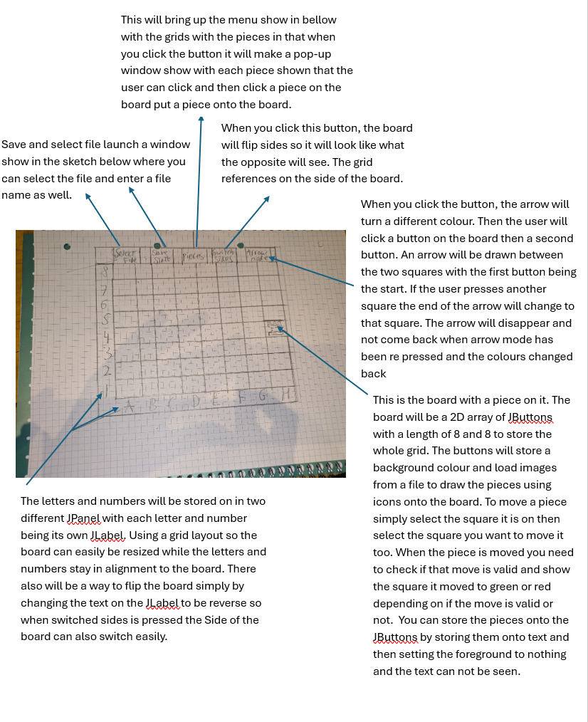

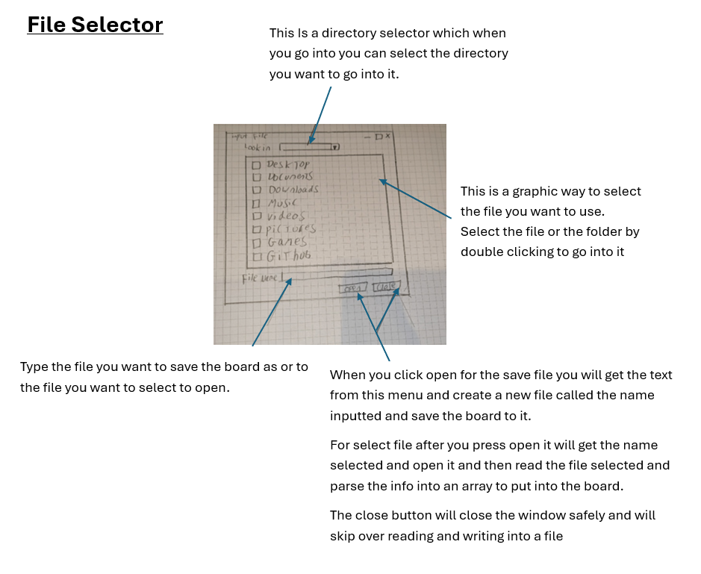

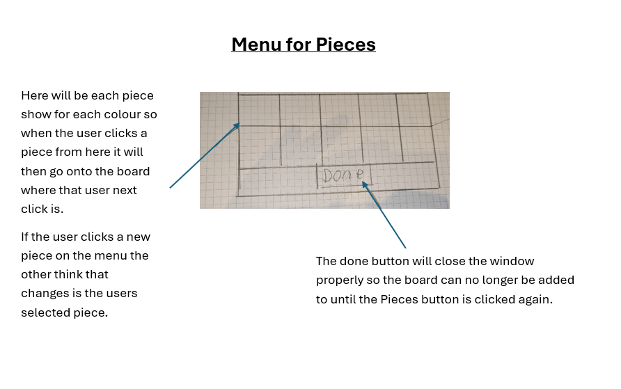

Class Structure

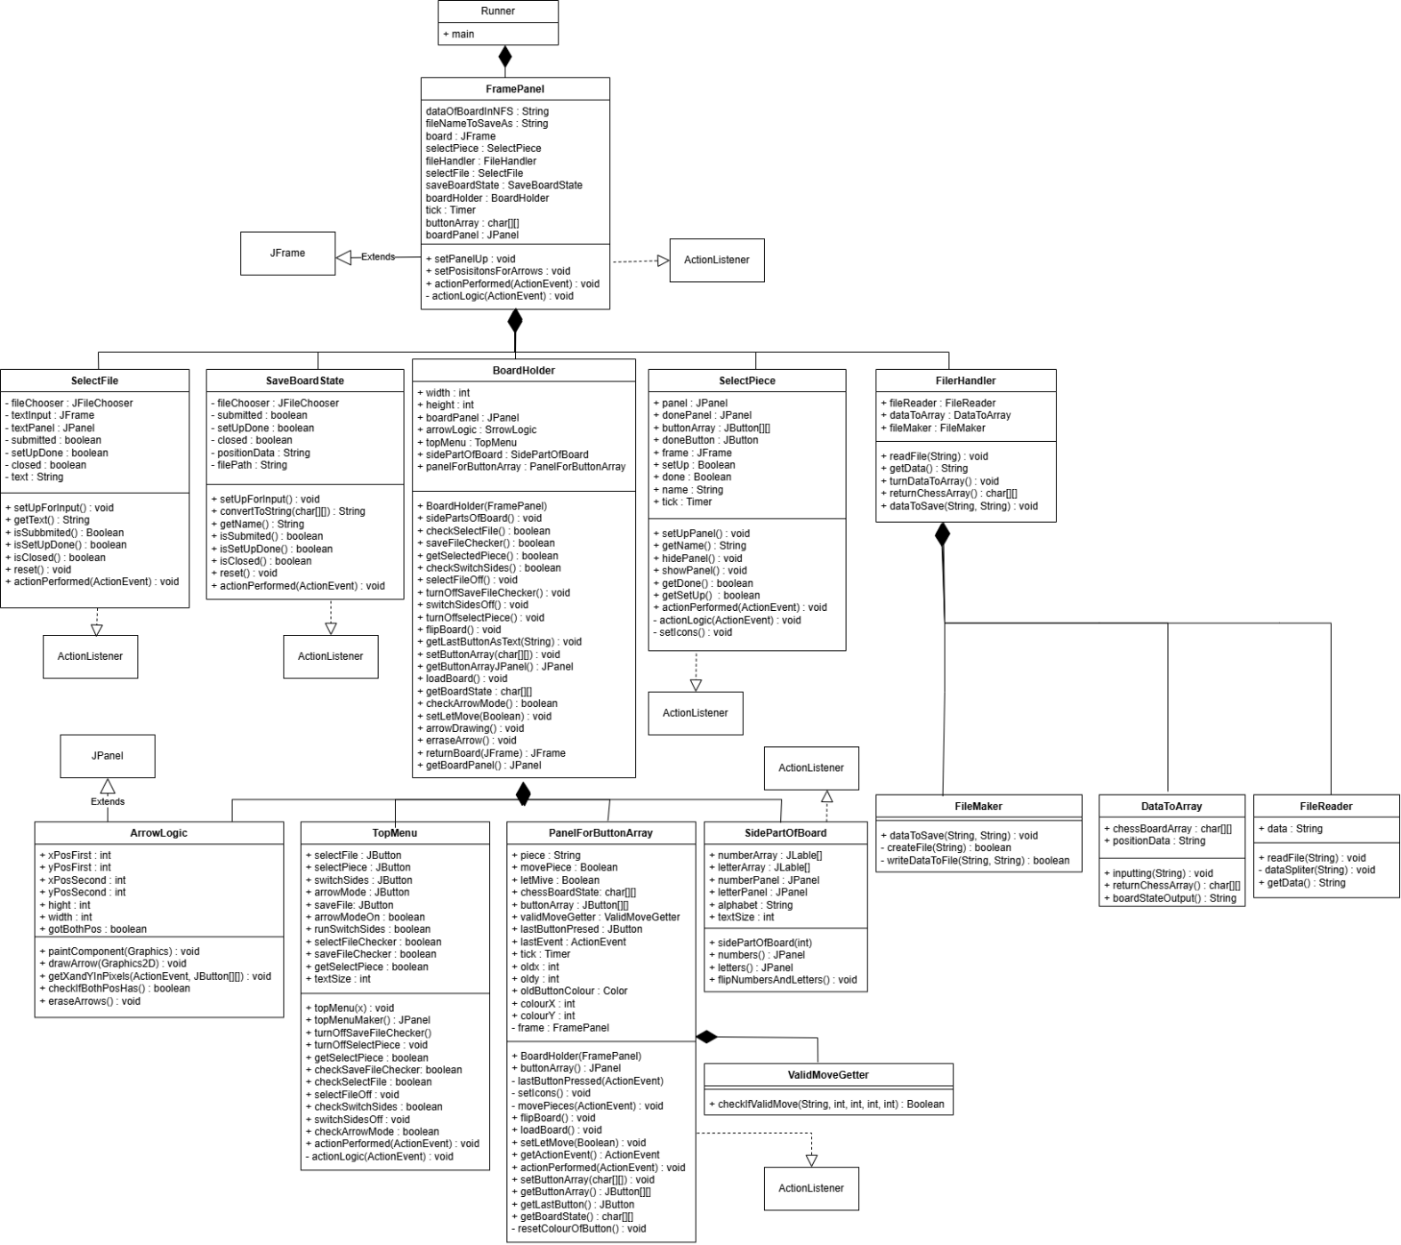

Algorithms

CLASS: runner
This class runs the program

METHOD: main
Creates a frame Panel

---------------------------------------------------------------------------------------------------------------------------------------------------

CLASS: FramePanel
This class runs holds the Jframe used to display everything and is used to move data to each class needed.

METHOD: FramePanel
This method sets up framePanel loading a map and creating the board using the subclasses functions.

METHOD: setUpPanel
This method sets adds the button array of the map and uses subclasses to create the board and the other buttons in the panel which displays everything the user sees
Check whether arrow mode is enabled

IF arrow mode is enabled
Disable player movement
Draw the arrow
ELSE
Remove the arrow
Enable player movement
END IF

METHOD: setPosisitonsForArrows
Checks if the arrow button has been pressed if so, it makes it so the pieces can’t move and lets the arrow drawing if the arrow button is false then it erased the arrow and sets let move as true.

When an action occurs

IF a piece is selected
Record the selected piece
IF the piece is not set up
Set up the piece interface
END IF

IF the piece is finished
Deselect the piece
Hide the piece interface
ELSE
Show the piece interface
END IF
END IF

METHOD: actionLogic

This will contain the logic for the action listener so the action listener will call this method and will run through this method to see what logic needs to be done if a certain action is taken. So, if a button is pressed.

METHOD: actionPerformed
If an action is triggered, then it will call actionLogic to do the logic for that action

---------------------------------------------------------------------------------------------------------------------------------------------------

CLASS: SelectFile
This is used so when the user can select the file for the board to load.

METHOD: setUpForInput
Configure the file chooser to accept text files only

Configure the text input window
Keep the window on top
Allow resizing
Set window size
Center the window on screen
Close the window when dismissed

When the window is closed
Mark the window as closed
END WHEN

Register the current object to handle file chooser actions

Add the file chooser to the interface
Display the text input window

Mark setup as complete
Reset the closed status

Creates the FIleNameExtention and the panel to put it on and a way to close it safely without it breaking and give the fileChoser a action listener then sets the panel as visible. Then makes setup equal to true and closed set as false.

METHOD: getText
This is a getter to get the value of the variable.

METHOD: isSubmitted
This is a getter to get the value of the variable.

METHOD: isSetUpDone
This is a getter to get the value of the variable.

METHOD: isClosed
This is a getter to get the value of the variable.

METHOD: reset
This class resets the variables all to their default state.

METHOD: actionPerformed
This checks what the fileChosser has returned and if it is a valid file and return the file selected or if it should close the window
Get the user’s action command

IF the user approves the file selection
Mark the input as submitted
Store the selected file location
Mark the window as open
Close the text input window

ELSE IF the user cancels the selection
Mark the input as not submitted
Mark the window as closed
Close the text input window
END IF

---------------------------------------------------------------------------------------------------------------------------------------------------

CLASS: SaveBoardState
This is used to select the area and the file name to save the board you have created.

METHOD: setUpForInput
Creates the fileChooser and puts it into save dialog mode

METHOD: convertToString
This method takes 2D array of characters and converts it to a string to save into a file and converts it to BNF like format.
Create an empty position string
Set an empty-square counter to zero

FOR each row of the board
FOR each square in the row
IF the square is empty
Increase the empty-square counter
ELSE
IF there were empty squares before
Add the count to the position string
END IF
Add the piece symbol to the position string
Reset the empty-square counter
END IF
END FOR

IF the row ends with empty squares
Add the count to the position string
END IF

Separate rows in the position string
Reset the empty-square counter
END FOR

Remove the final row separator
Return the position string

METHOD: getName
This is a getter to get the value of the variable.

METHOD: isSubmitted
This is a getter to get the value of the variable.

METHOD: isSetUpDone
This is a getter to get the value of the variable.

METHOD: isClosed
This is a getter to get the value of the variable.

METHOD: reset
This class resets the variables all to their default state.

METHOD: actionPerformed
Checks what the use clicks on the filechooser and if its valid and then acts according for what the user clicks. Either it closes the program or approves the file and gets it path.

---------------------------------------------------------------------------------------------------------------------------------------------------

CLASS: BoardHolder
This is the class used to contain all the stuff needed to work with the board and what the user sees like the top menu and the side menu as well as the main board.

METHOD: BoardHolder
Creates the main board used and passes it FramePanel

METHOD: checkSelectFile
Calls the topMenu to check is selectFile has been pressed

METHOD: saveFileChecker
Calls the topMenu to check is saveFile has been pressed

METHOD: getSelectedPiece
Calls the topMenu to check is selectPiece has been pressed

METHOD: checkSwitchSides
Calls the topMenu to check is SwitchSides has been pressed

METHOD: selectFileOff
Tells topMenu to set selecFile button to false

METHOD: turnOffSaveFileChecker
Tells topMenu to set saveFile button to false

METHOD: switchSidesOff
Tells topMenu to set switchSdes button to false

METHOD: turnOffselectPiece
Tells topMenu to setselectPiece button to false

METHOD: flipBoard
Calls the main board flip method to flip the board

METHOD: getLastButtonAsText
Ask the main board to get the last button presses on the board and set the button text as the text given in the method

METHOD: setButtonArray
Sets the chess button array as the one that is imputed into the method.
METHOD: getButtonArrayJPanel
Returns a JPanel of the button array

METHOD: loadBoard
Runs the loadBoard method in the mainboard class

METHOD: getBoardState
Returns a 2D array of the current board that is displayed

METHOD: setLetMove
Takes a Boolean and then gives it to the chess board setMove Function to see if the pieces can move

METHOD: checkArrowMode
Calls topMenu to see if ArrowMode is active

METHOD: arrowDrawing
Create the main board panel

Get the screen dimensions
Set the board size to match the screen

Configure the main board window
Close the application when the window closes
Display the window

Create a layered interface
Place the board on the base layer
Place arrow graphics above the board
Make the arrow layer transparent

Set the layered interface size to match the window
Resize the board and arrow layers to fit the playing area

Add all interface components to the board
Place the layered interface in the center
Place the menu at the top
Place number labels on the left
Place letter labels at the bottom

Return the configured board
Calles arrowLogics getXAndYOfButtonInPixels method and takes the last button pressed and the board for the arrowLogic Method.

METHOD: erraseArrow
Calls arrowLogic erraseArrow method to erase the arrow that is draw on the board.

METHOD: getBoardPanel
Returns the JPanel used full of the board

METHOD: returnBoard
Takes and returns a Jframe. This method creates the board with layed panels and a set screen width and hight and sets up the Jframe for use by adding all the necessary components needed.

---------------------------------------------------------------------------------------------------------------------------------------------------

CLASS: SelectPiece
Creates the panel of pieces used to select when building a board.

METHOD: setUpPanel
Creates the Jframe and Panel of the board and adds the panel text of the pieces on it

METHOD: getName
Returns the name of the piece that has been selected

METHOD: hidePanel
Sets the visibility of the Jframe to false

METHOD: showPanel
Sets the visibility of the Jframe to true

METHOD: getDone
Return if the done button has been clicked to close the panel

METHOD: getSetUp
Return if the window set up has been completed

METHOD: setIcons
FOR each relevant square on the board
Read the piece identifier from the square

IF a piece is present
Choose the correct image for that piece
Display the image on the square
END IF
END FOR
Sets the icons of the panel with images using a switch case

METHOD: actionLogic
Preforms the action logic for the class to get which button is pressed and then get the text from it

METHOD: actionPerformed
Calls action Logic with the even for the logic.

---------------------------------------------------------------------------------------------------------------------------------------------------

CLASS: FileHandler
Holds everything to do with the actual files in the project and has it all in one class

METHOD: readFile
Calls fileRead with a string to read that file

METHOD: getData
Readers fileRead data that was read from the above method

METHOD: turnDataToArray
Gets the data from the method above and puts it into dataToArray inputting method to turn it into a array

METHOD: returnChessArray
Returns a 2D array of characters that was made In the method above

METHOD: dataToSave
Takes a file name and a board state both as strings and then uses file maker dataToSave method to save the file.

---------------------------------------------------------------------------------------------------------------------------------------------------

CLASS: ArrowLogic
Does everythink to draw and erase the arrow and get the positions.

METHOD: paintComponent
Is the paint component that is used to easily to draw the arrow

METHOD: drawArrow
Does the maths to draw the arrow and sets it colour with paint component

Set color to red
Set stroke thickness

Draw line from (startX, startY) to (endX, endY)

Compute direction = angle from start to end

Set arrowhead size

Create arrowhead shape at (endX, endY)

Rotate arrowhead by direction

Draw and fill the arrowhead

Reset drawing transformations

METHOD: getXAndYOfButtonInPixels
Gets the x and y of the buttons and stores them
IF first position is not set
FOR each row in board
FOR each column in board
IF the clicked button matches this square
Set first position to the center of this square
gotBothPos = FALSE
END IF
END FOR
END FOR
ELSE
FOR each row in board
FOR each column in board
IF the clicked button matches this square
Set second position to the center of this square
Set width and height of the square
gotBothPos = TRUE
END IF
END FOR
END FOR
END IF

METHOD: checkIfBothPosHave
Returns a Boolean value of gotBothPos which is true if both values for the arrow positions to draw.

METHOD: eraseArrows
Sets all the values to their default value and removes the arrows positions

---------------------------------------------------------------------------------------------------------------------------------------------------

CLASS: TopMenu
This is the class that contains all the buttons that the user can press in the top menu

METHOD: TopMenu
Takes a integer and then sets it as the textSize used in topMenu button text Size

METHOD: topMenuMaker
Creates the JPanel and creates the buttons adds the action Listener for it with the buttons fonts and backgrounds and adds it to the panel.
CREATE a new panel

CREATE button "Select File"
Set background color to white
Set font size
Register action listener
Add button to panel

CREATE button "Save State"
Set background color to white
Set font size
Register action listener
Add button to panel

CREATE button "Pieces"
Set background color to white
Set font size
Register action listener
Add button to panel

CREATE button "Switch Sides"
Set background color to white
Set font size
Register action listener
Add button to panel

CREATE button "Arrow Mode"
Set background color to white
Set font size
Register action listener
Add button to panel

RETURN the panel

METHOD: turnOffSaveFileChecker
Turns the Boolean variable saveFileChecker to false

METHOD: turnOffSelectPiece
Turns the Boolean variable getSelectPiece to false

METHOD: selectFileOff
Turns the Boolean variable selectFileCheck to false

METHOD: switchSidesOff
Turns the Boolean variable runSwitchSides to false

METHOD: getSelectPiece
Returns the Boolean value of getSelectPiece

METHOD: checkSaveFileChecker
Returns the Boolean value of saveFileChecker

METHOD: checkSelectFile
Returns the Boolean value of selectFileCheck

METHOD: checkSwitchSides
Returns the Boolean value of runSwitchSides

METHOD: checkArrowMode
Returns the Boolean value of arrowModeOn

METHOD: actionLogic
Does the logic for action performed. If a button is selected it turns that buttons Boolean variable to true.

METHOD: actionPerformed
Runs actionLogic with the action that triggered this as the input

---------------------------------------------------------------------------------------------------------------------------------------------------

CLASS: PanelForButtonArray
This holds the chess board array and everything needed to be needed with the chess board.

METHOD: PanelForButtonArray
Starts the timer and gives the class the JFrame to be use in the board.

METHOD: buttonArray
Creates the panel used in the button array and adds the buttons to it. Then loads the board.

METHOD: lastButtonPresed
When a event is made this will store the button that caused the action.
FOR each row in the relevant board area
FOR each column in the relevant board area
Get the piece symbol from the square

SELECT the piece symbol
CASE "P":
Set the square’s image to white pawn
CASE "R":
Set the square’s image to white rook
CASE "N":
Set the square’s image to white knight
CASE "B":
Set the square’s image to white bishop
CASE "Q":
Set the square’s image to white queen
CASE "K":
Set the square’s image to white king
// Add other piece cases as needed
END SELECT
END FOR
END FOR
METHOD: setIcons
Uses a switch case to load the images onto the tile.

METHOD: actionPerformed
Sets the lastAcrionEvent as the event that triggered this then runs moves pieces with the actionEvent selected and runs lastButtonPressed with the input of the event that triggered this. Then finally it sets the icons of all the pieces.

METHOD: loadBoard
Goes through the whole chess array. Sets there icons as null and then sets the text of the button as the chessArrays text at that position of the array.

METHOD: setLetMove
It takes a Boolean variable and sets letMove to that variable given

METHOD: getActionEvent
Returns the lastEvent

METHOD: setButtonArray
Takes a 2D array of characters and sets it as the chessArray

METHOD: getButtonArray
Returns the 2D array of JButtons

METHOD: getLastButton
Returns the last Button Pressed

METHOD: getBoardState
Takes the chess board and takes the text of it and puts it to a array that is then return from the method

METHOD: resetColourOfButton
Gets the last button pressed and then resets it to its old colour.

METHOD: movePieces
IF a piece is being moved AND the current square is not empty
Store the piece from the square
Remove the piece’s image
Remember the old coordinates
Mark movePiece as FALSE
Clear the text from the square
Reset the square’s background color
ELSE IF no piece is currently being moved
Store the current square’s background color
Remember the coordinates of the square

IF the move from the old position to this square is valid
Highlight the square green
ELSE
Highlight the square red
END IF

Set the square’s text to the piece
Mark movePiece as TRUE
END IF
This is the class to move the pieces. When a action is done this method is called and if letMove is true then it searches for the button that pressed it. If it is a piece then its will store it and remove the icon when moving to the next button.

METHOD: flipBoard
Flips the whole board in the x and y axis. So, the pieces are flipped in so you can see the pieces for the opponent’s side.
CREATE a new 8x8 flipped button array

FOR each square on the board
Clear the square’s image
END FOR

FOR each square in the flipped array
Initialize a new button
END FOR

// Flip the board along both axes
FOR each row in the board
FOR each column in the board
Set the flipped array’s square to the text from the mirrored square of the original board
END FOR
END FOR

// Copy the flipped board back to the original
FOR each row in the board
FOR each column in the board
Update the original board’s square with the flipped square’s text
END FOR
END FOR

Reset the colors of all buttons
---------------------------------------------------------------------------------------------------------------------------------------------------

CLASS: SidePartsOfBoard
Contains the side of the board with all the numbers and letters

METHOD: SidePartsOfBoard
Takes a integer and then sets it as the textSize used in topMenu button text Size

METHOD: Numbers
Creates a JPanel with a set of JButtons using a grid layout. It returns the JPanel. This panel has the numbers as the set Text

METHOD: Letter
Creates a JPanel with a set of JButtons using a grid layout. It returns the JPanel. This panel has the letters as the set Text

METHOD: flipNumbersAndLetters
Flips both the letters and number panel text so 1-8 becomes 8-1 and the same for the letters

---------------------------------------------------------------------------------------------------------------------------------------------------
CLASS: FileMaker
FUNCTION createFile(name)
TRY
Create a file object with the given name
IF the file does not already exist
Create the file
RETURN TRUE // file successfully created
ELSE
RETURN FALSE // file already exists
END IF
CATCH any error
Print error details
RETURN FALSE // error occurred
END TRY
END FUNCTION

FUNCTION writeDataToFile(name, data)
Convert the data to bytes
TRY
Write the bytes to the file with the given name
RETURN TRUE // write successful
CATCH any error
Print error details
RETURN FALSE // write failed
END TRY
END FUNCTION
Is the class to make the file for them to be saved

METHOD: dataToSave
Takes a name and data as inputs off Strings and then runs createFile with the name and wrteDataToFile to save the data into the file

METHOD: createFile
Creates the file with the file object and then saves it

METHOD: writeDataToFile
Gets the path of the file and then opens it and writes the data into the file.

---------------------------------------------------------------------------------------------------------------------------------------------------

CLASS: DataToArray
Gets the strings and then turns them to the chess array from BNF format to a 2D character array
Initialize nextLineCount to 0
Initialize xAxis to 0
Initialize skipRest to FALSE
Initialize positionData to empty

FOR each character in the input data
IF character is a space
skipRest = TRUE

ELSE IF character is a digit AND skipRest is FALSE
repeatCount = numeric value of character
FOR repeatCount times
Set chessBoardArray[xAxis][nextLineCount] to empty
xAxis += 1
END FOR

ELSE IF skipRest is TRUE
Append character to positionData

ELSE IF character is not a digit AND skipRest is FALSE
IF character is '/'
nextLineCount += 1
xAxis = 0
ELSE
Set chessBoardArray[xAxis][nextLineCount] to character
xAxis += 1
END IF
END IF
END FOR
METHOD: Inputing
Takes each charter and converts it to the 2D array

METHOD: returnChessArray
Returns the chess array

METHOD: boardStateOutput
Returns a string version of the chess array

---------------------------------------------------------------------------------------------------------------------------------------------------
CLASS: FileReader
The class that’s reads the data from the file

METHOD: readFile
Takes a file name and reads the data out of it.

METHOD: dataSpliter
Splits up the data and adds It to the the DataString

METHOD: getData
Returns the data string

---------------------------------------------------------------------------------------------------------------------------------------------------
CLASS: ValidMoveGetter
Class to see if a move is valid or not

METHOD: checkIfValidMove
Uses maths to get the diffrents of the moves and then uses the piece to get to see if the move is valid or not.

Compute xdiff = absolute difference between lastX and newX
Compute ydiff = absolute difference between lastY and newY

Convert xdiff and ydiff to absolute values

SELECT the piece type (uppercase)
CASE "P": // Pawn
IF the pawn is on its starting row
IF xdiff is 1 OR xdiff is 2
RETURN TRUE // valid move
END IF
ELSE
IF xdiff is 1
RETURN TRUE // valid move
END IF
END IF
END CASE
// Other piece cases would go here
END SELECT

Technical Solution

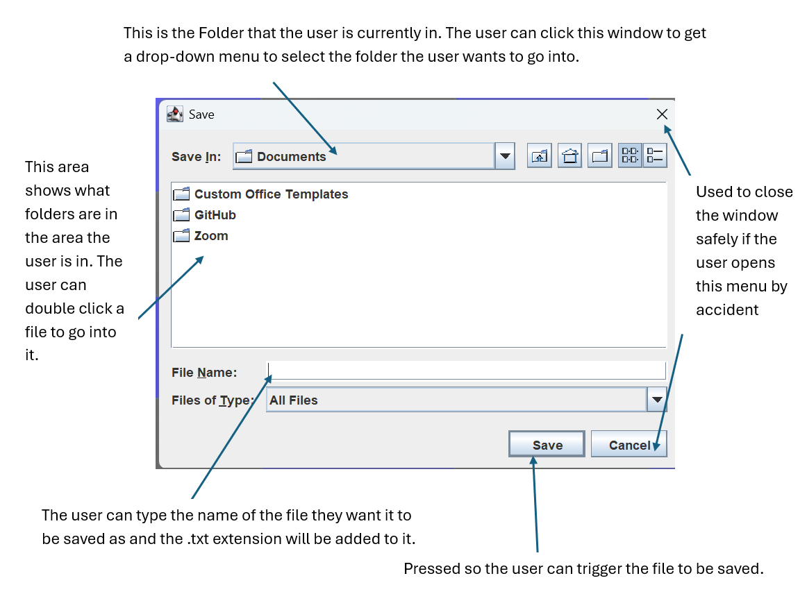
Final product

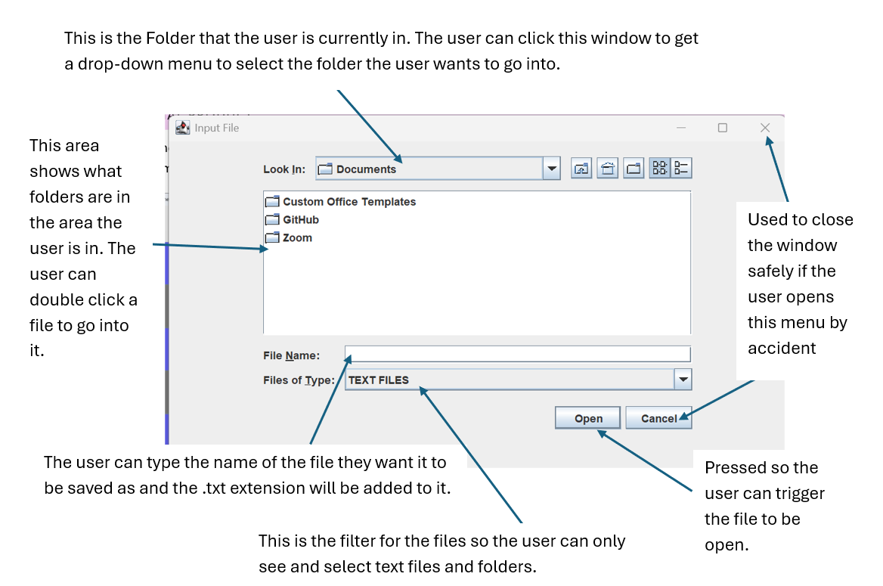
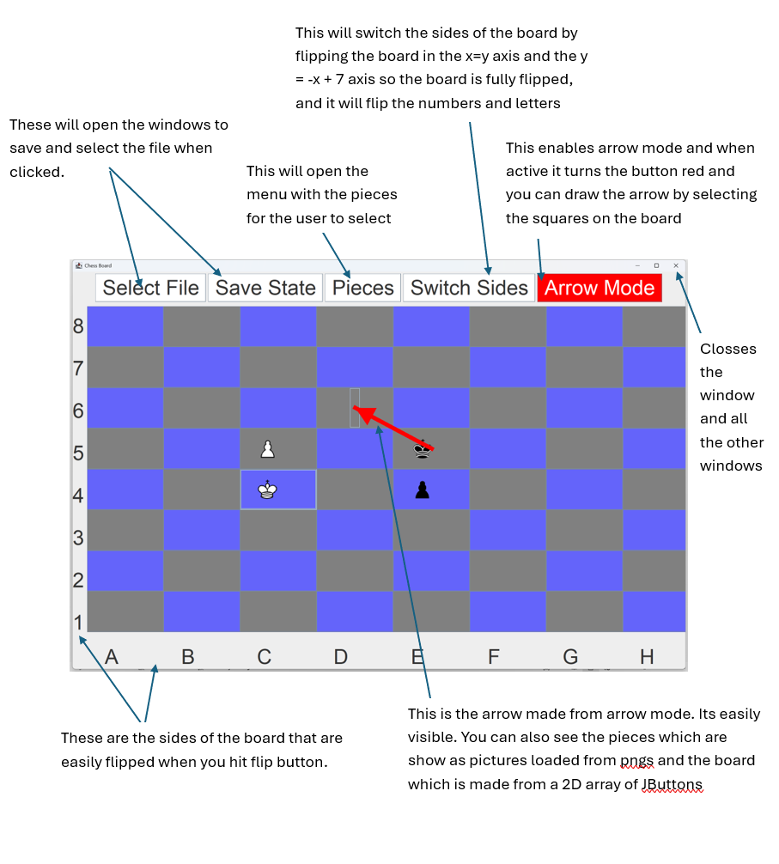

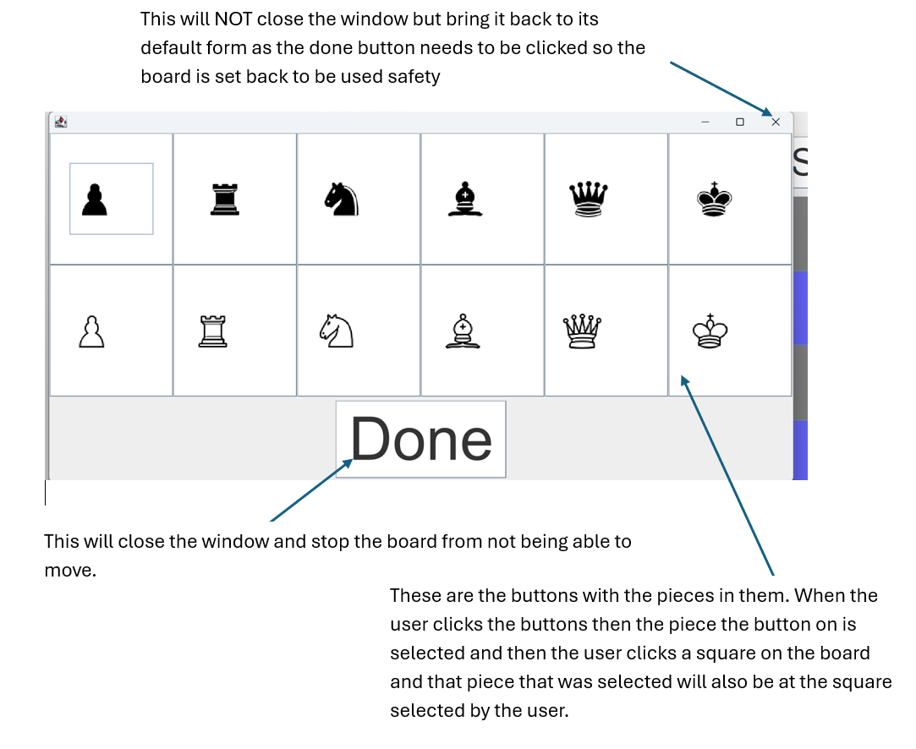

Code Segments

Anythink complect

CLASS: FramePanel

Logic used for showing save and select windows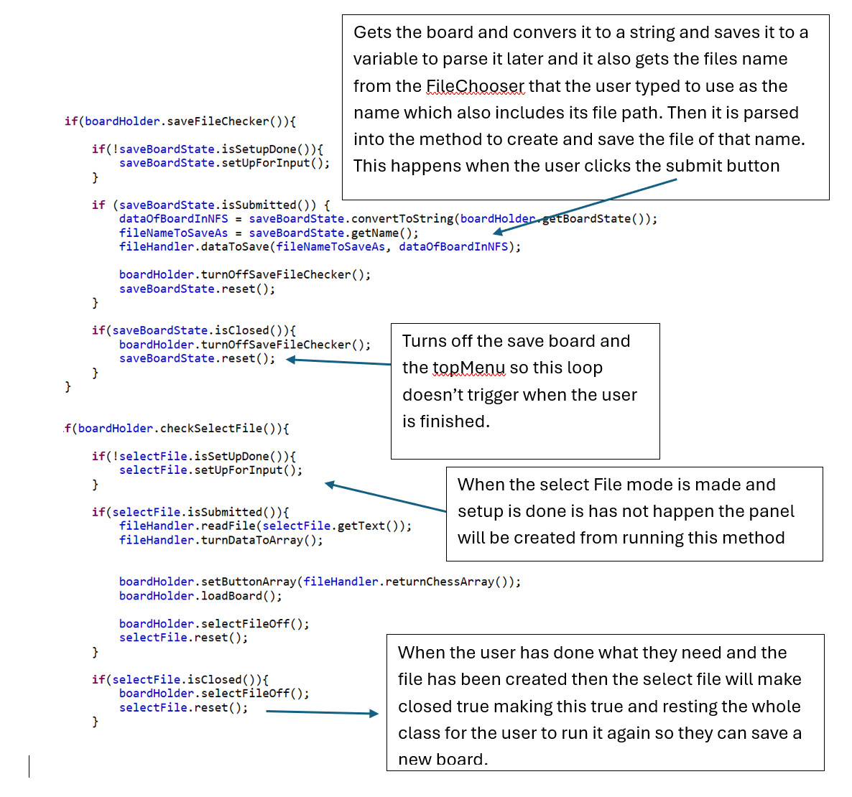

CLASS: SelectFile

Makes the JFileChooser and sets it up.
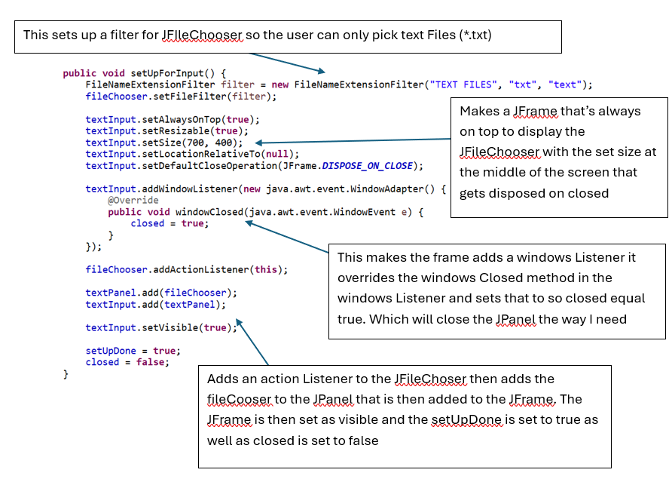
Handles when a user triggers an action in the JFileChooser
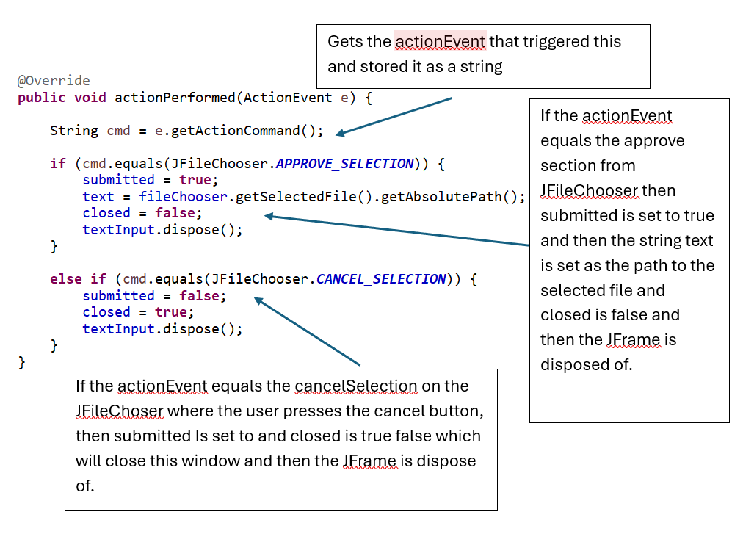

CLASS: SaveBoardState

When ran this will set up the JFileChooser ready to been seen by the user
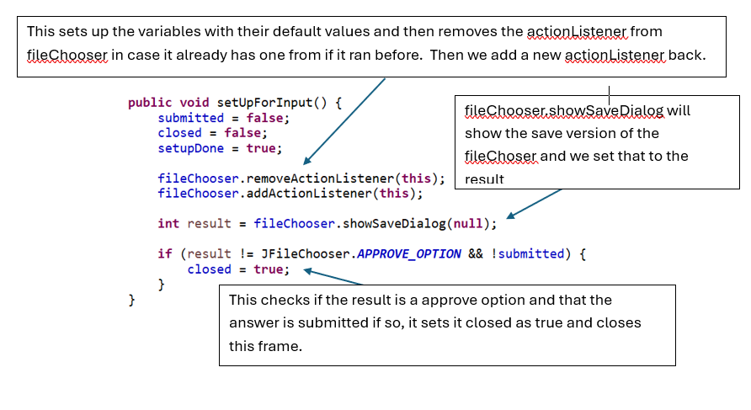

This converts the 2D array to a string in BNF format

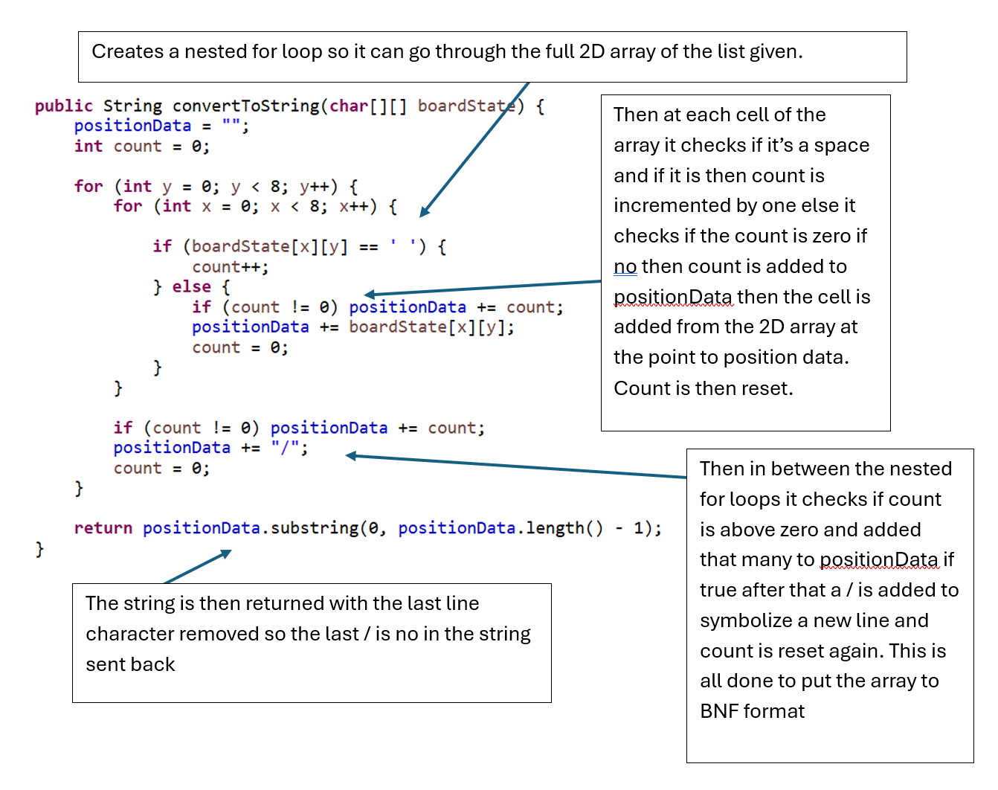

Handles when a user triggers an action in the JFileChooser (This is the same as the selectFile as they are doing the same thing needed at this point in both classes)

Testing
A test should be designed for each success criteria, and should be enough to evidence that the program fully works and meets all the success criteira

Test Table
Test Number | Success Criteria | Description | Expected outcome | Observed outcome | Remedial action (if necessary)
1 | 1 | Launch application, and start 1 player game | First level loads with a single yellow pacman | Game successfully started with one playe | None needed
2 | 1 | Launch application, and start 2 player game | Fist level loads with yellow and green pacman
3 | 2 | On menu screen, press left to change p1 colour and “a” to change p2 colour and start game | Both players should be their new colours
4

Evidence
Screenshot evidence where appropriate for each test

Test 1

Test 2
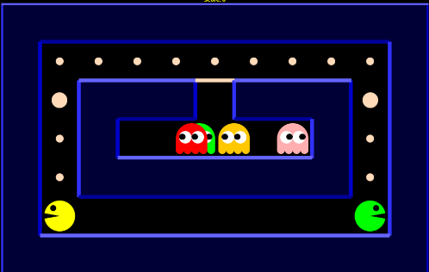

Evaluation

Analysis of Criteria
Include each of your success criteria along with a description (and reference to evidence if possible) with how you met it

End User Feedback
Include some feedback from your end user and analyse it to explain how successful your product was

Furhter development
If the product were to continue to be developed, how could this be done? What could be added or improved?

Final thoughts
Overall, how do you feel about your product and the experience of making it? (be positive)

